Business Case for Recreation and Wellness Intranet 9/22/2022
Project Name: Recreation and Wellness Intranet Project
- Introduction/ Background

In a recent study MYH found that they pay 20 percent more for employee healthcare premiums than the average employee in the industry

2.0 Business Objective

The business objective is to improve the health of employees in order to lower the insurance premiums for healthcare and provide savings.

3.0 Current Situation and Problem/Opportunity Statement
The current situation is that there is no program to improve health of employees which increases cost for healthcare premiums.

This project is to track data on health management to become more involved in exercise

4.0 Critical Assumption and Constraints
The project must work on its current intranet infrastructure, there is a budget of 200,000 for development and should be secure and private.

.
5.0 Analysis of Options and Recommendation
- The options for development are build it within current infrastructure
- Use outside resources to build it
- Don’t build the application at all and raise insurance costs for employees
- Recommendation: Develop the app within existing infrastructure

6.0 Preliminary Project Requirements
- Allow employees to register for different sports such as soccer, bowling, walking, and softball
- Register for company sponsored classes to help them manage weight and health issues
- Track their data and involvement in these programs
- Offer incentives to become involved in the programs and do well in them

7.0 Budget Estimate and Financial Analysis
The budget for the project is 200,000 to build it with an expected maintenance/upkeep of 40,000 yearly which is 20% of the original costs.

8.0 Schedule Estimate
The project should be completed within 6 months and should be fully usable after that time period

9.0 Potential Risks

- Employees don’t want to use the app
- Keeping employees engaged and wanting to continue using it
- Providing incentives that attract employees to join the app
- Security concerns with storing health data on an app

10.0 Exhibits
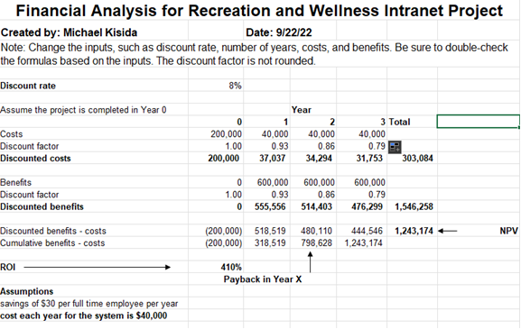Exhibit A: Financial Analysis

